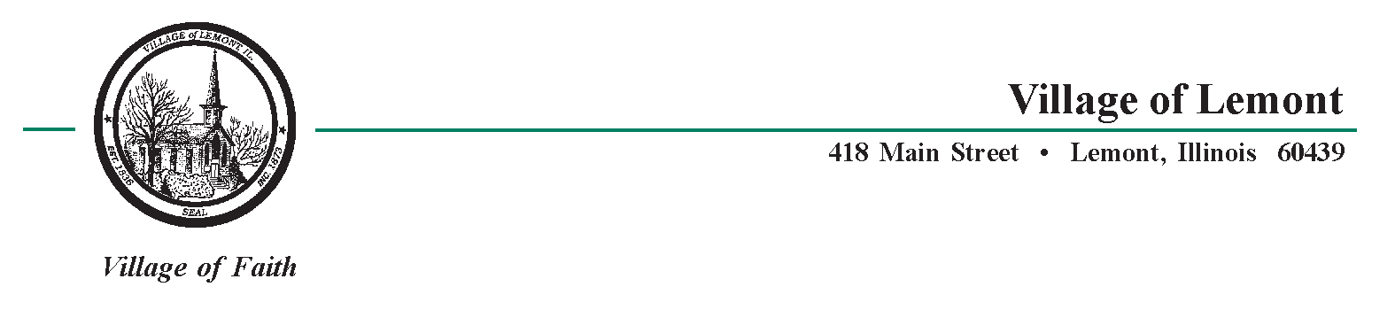

Liquor Control Review Board
January 14, 2013 - 6:00 p.m.
Village Hall – 418 Main St.
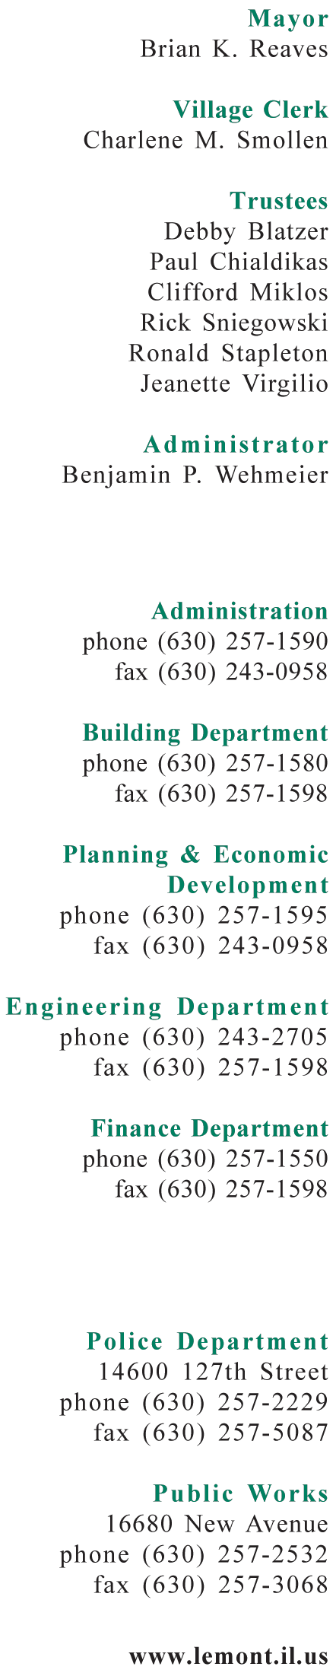
Agenda

- Call to Order
- Roll Call
Liquor Commissioner Brian Reaves, Art Garibay, Terry Lemming, Frank Wozniak
- Hearing for Ti Amo Ristorante Inc.
12350 Derby Road, Lemont, IL 60439
Class A-3 – license authorizes the retail sale of alcoholic liquor for consumption on or off the specified premises and permit live entertainment, if conforming – the requirements of a restaurant: Any public area where food is served for consideration at tables, on a daily basis, is licensed as a restaurant, and where over one third (1/3) of the gross revenue is derived from sale of food. Such area shall not include the lounge area or bar of premises.
- Liquor Commissioner comments.
- Petitioner presents application.
- Commissioners questions.
- Police Department comments.
- Petitioner excused.
- Commission’s Deliberation, Decision & Instructions
- Post-hearing action – Written Notice to be Given Within 10 Days.
- Old Business
- New Business
- Adjourn

